Multivariate bias correction improves inter-station dependence relative to QDM in multi-site daily precipitation across a coastal gauge network in Thailand
Surasit Punyawansiri^{1,*}
¹Office of Water Management and Hydrology, Royal Irrigation Department, Bangkok, Thailand
*Corresponding author: Surasit.pun@thaimooc.ac.th
Article type: Research article

Abstract
Bias correction of climate-model precipitation is often evaluated station by station, although distributed hydrological applications also require realistic dependence among gauges. We compared N-dimensional multivariate bias correction (MBCn), quantile delta mapping (QDM), and uncorrected CMIP6 precipitation for 12 daily rain gauges in Prachuap Khiri Khan Province, Thailand, using seven CMIP6 models. Bias-correction parameters were fitted using 1981–2000 and evaluated independently over 2001–2014. The revised analysis strictly restricted all multivariate operations to the 12 stations specified in the study design and implemented MBCn as calendar-month blocks with 25 seeded orthogonal-rotation passes. Because QDM values are restored at each station within each month, QDM and MBCn were identical for the six station-level validation diagnostics. Relative to QDM, MBCn reduced standardized energy distance from 0.139 to 0.104, Spearman correlation-matrix RMSE from 0.286 to 0.157, Pearson RMSE from 0.374 to 0.124, and wet-day occurrence RMSE from 0.273 to 0.111. The corresponding improvements were 25.5%, 45.1%, 66.8%, and 59.2%, respectively, and all seven models favoured MBCn for these endpoints. The exact one-sided paired Wilcoxon test gave p = 0.0078 for each primary correlation endpoint, with Holm-adjusted p = 0.0234 and matched-pairs rank-biserial effect size = 1.00. Normalized joint-q95 RMSE also improved in all seven models, whereas the observed-threshold sensitivity metric improved in six of seven. Robustness tests showed that most dependence improvement occurred within approximately 5–10 iterations, while the 25-pass production setting remained a pre-specified fixed configuration rather than a validation-tuned optimum. Temporal diagnostics showed a trade-off: MBCn improved several autocorrelation measures but altered wet/dry persistence and Rx5day, indicating that spatial-dependence gains do not imply universal temporal improvement. Future projected wet-day quantile changes remained broadly comparable to QDM, with mean absolute deviation from raw model change signals of 9.66 percentage points for MBCn and 10.32 percentage points for QDM. These results support QDM for applications requiring only marginal fidelity, whereas MBCn is preferable when inter-station dependence is an explicit requirement, provided temporal consequences are also evaluated.
Keywords: multivariate bias correction; MBCn; inter-station dependence; multi-site precipitation; CMIP6

1. Introduction
Global climate models remain too coarse for direct use at catchment and station scales, and their daily precipitation contains systematic errors in both occurrence and intensity [1]. Distribution-based bias correction is therefore standard in hydrological climate-impact studies [2], [3]. Quantile delta mapping (QDM) is widely used because it adjusts the full distribution at a site while preserving the model-projected relative change at each quantile [4]. This is usually sufficient when the analysis treats each gauge independently.
QDM does not directly control relationships among gauges because each site is corrected independently. This limitation matters when corrected fields drive distributed hydrological models, joint flood analyses, or assessments of spatially extensive droughts and storms. Accurate marginal distributions can coexist with an unrealistic joint structure, and such errors propagate into analyses of compound and spatially concurrent extremes [5].
Multivariate methods address the joint distribution explicitly. Examples include rank-based resampling [6], optimal transport [7], and N-dimensional multivariate bias correction (MBCn) [8]. MBCn repeatedly rotates the multistation field, quantile-maps each rotated component to the corresponding observations, and reverses the rotation; a final step reinstates the QDM marginal values at each gauge. Comparative studies show that multivariate adjustment can improve dependence while introducing method-specific trade-offs [9], and regional applications confirm the relevance of evaluating spatial as well as marginal behaviour [10].
The final rank-substitution step determines how QDM and MBCn should be compared. Because MBCn restores the QDM values at every gauge, the two methods must be identical for distribution-based single-site diagnostics. Their added value can therefore be judged only with diagnostics that measure dependence among gauges.
The spatial organisation of rainfall extremes is both consequential and uncertain under climate change [11]. CMIP6 studies have evaluated precipitation change across mainland Southeast Asia [12]-[14] and Thailand [15]-[18], while recent work has compared correction methods in multistation settings [19]. However, few studies combine an independent validation period with several complementary dependence diagnostics in one gauge-network experiment. We therefore ask: once single-site performance is fixed by construction, how much does MBCn improve the joint behaviour of a coastal gauge network, and does it compromise numerical stability or the projected quantile-change signal?

2. Materials and Methods

2.1 Study area and rain-gauge network
Twelve daily rain gauges in Prachuap Khiri Khan Province, on the western shore of the Gulf of Thailand, were used as the observed network (Table 1 and Figure 1). The records cover 1 January 1981 to 31 December 2014. Mean annual precipitation ranges from approximately 944 to 1,376 mm, while wet-day frequency varies substantially among gauges. The final analysis uses exactly the 12 stations specified in the manuscript: 500001, 500002, 500003, 500004, 500005, 500006, 500007, 500008, 500009, 500201, 500202, and 500301. The source archive contains additional stations, but these were excluded before fitting and before every multivariate operation.
Coordinates and elevations were taken from the project station metadata and filtered to the same 12-station network. Figure 1 provides geographic context only; elevation is not used as a predictor in the bias-correction procedure. The observed Prachuap Khiri Khan subset contains 12,418 daily records over the study period and is gap-free for the 12 selected gauges.
Table 1. Characteristics of the twelve rain gauges, 1981–2014.

Station | Latitude (°N) | Longitude (°E) | Elevation (m) | Mean annual rainfall (mm) | Wet-day frequency (%)
500001 | 12.370 | 99.950 | 8 | 983.70 | 22.23
500002 | 11.180 | 99.550 | 0 | 1,376.20 | 33.73
500003 | 12.020 | 99.900 | 0 | 1,100.00 | 22.93
500004 | 11.470 | 99.650 | 0 | 1,106.00 | 26.34
500005 | 11.600 | 99.680 | 6 | 1,147.20 | 47.96
500006 | 11.620 | 99.670 | 24 | 1,203.10 | 49.77
500007 | 11.900 | 99.780 | 24 | 1,133.60 | 48.66
500008 | 12.530 | 99.550 | 128 | 1,206.30 | 62.63
500009 | 12.220 | 99.870 | 13 | 1,176.50 | 60.15
500201 | 11.830 | 99.830 | 64 | 1,108.20 | 24.70
500202 | 12.590 | 99.960 | 0 | 944.10 | 21.53
500301 | 12.580 | 99.730 | 106 | 1,064.80 | 25.33
Coordinates (WGS84) and elevations are from the project metadata archive; rainfall statistics are computed from the gap-free observed daily record. A wet day is defined throughout as at least 1 mm of rainfall.
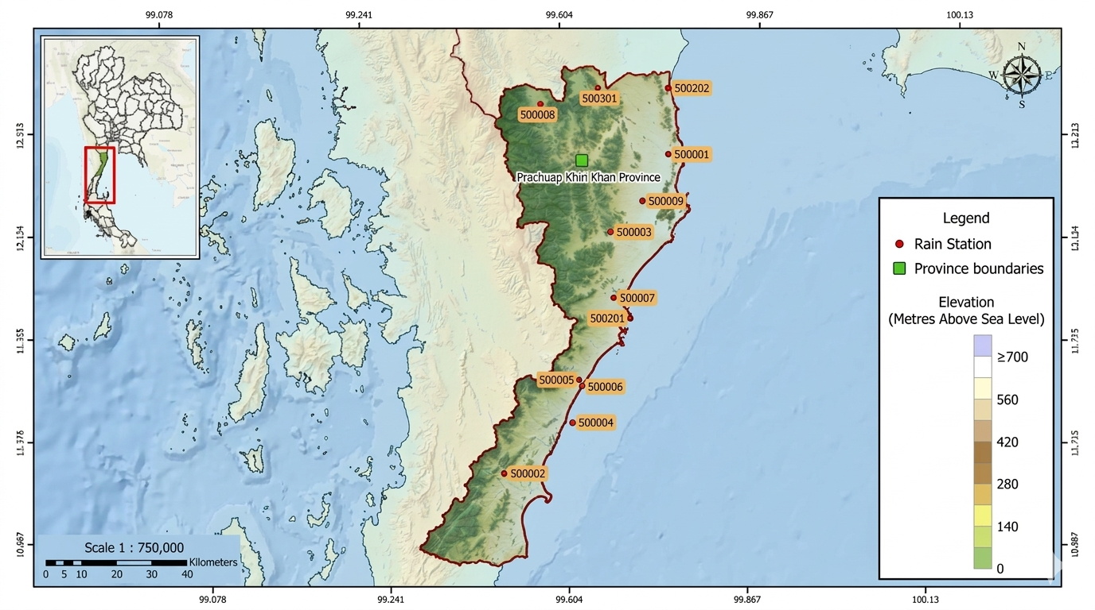
Figure 1. Location of the 12 selected rain gauges in Prachuap Khiri Khan Province, Thailand. Labels identify the stations used in every fitting and evaluation step.

2.2 Climate models and experimental design
Seven CMIP6 models were analysed: ACCESS-ESM1-5, CanESM5, CESM2, EC-Earth3, FGOALS-g3, MIROC6, and MRI-ESM2-0. The selected model files provide daily precipitation at the gauge locations for the historical period and the SSP2-4.5 and SSP5-8.5 pathways. CESM2 uses r11i1p1f1; the other six models use r1i1p1f1. All model fields were restricted to the same 12 station identifiers before fitting or evaluation.
A common temporal split was applied to every method: 1981–2000 for calibration and 2001–2014 for independent validation. Validation observations were not used in fitting. Historical and future corrected series were generated for 1981–2014 and 2015–2100, respectively. Future periods were summarized as near future (2021–2040), mid-century (2041–2060), and late century (2081–2100).

Model | Institution | Ensemble member | Grid label
ACCESS-ESM1-5 | CSIRO, Australia | r1i1p1f1 | gn
CanESM5 | CCCma, Canada | r1i1p1f1 | gn
CESM2 | NCAR, United States | r11i1p1f1 | gn
EC-Earth3 | EC-Earth Consortium, Europe | r1i1p1f1 | gr
FGOALS-g3 | CAS, China | r1i1p1f1 | gn
MIROC6 | MIROC, Japan | r1i1p1f1 | gn
MRI-ESM2-0 | MRI, Japan | r1i1p1f1 | gn
Table 2. The seven CMIP6 models and their configuration.
All seven models provide daily precipitation for the historical experiment (1981–2014) and for both SSP2-4.5 and SSP5-8.5. Labels were verified against the archive filenames. gn = native model grid; gr = regridded.

2.3 Bias-correction methods
Quantile delta mapping (QDM) was applied independently to each gauge and calendar month. Let $F_{o}$and $F_{m}$denote the empirical cumulative distribution functions of observed and simulated precipitation during the calibration period, respectively. For a simulated value $x$, its model quantile was first determined as
$$\begin{matrix} & u=F_{m}\left(x\right), & & \text{(7)}\end{matrix}$$
and the corresponding observed quantile was obtained from the inverse observed distribution. For relative QDM, the bias-corrected value was calculated as
$$\begin{matrix} & x_{QDM}=F_{o}^{-1}\left(u\right)\frac{x}{F_{m,b}^{-1}\left(u\right)}, & & \text{(8)}\end{matrix}$$
where $F_{m,b}^{-1}\left(u\right)$is the model quantile at the same probability during the baseline period. This formulation preserves the relative model-projected change at each quantile [4].
MBCn was initialized with the QDM-corrected precipitation field and then applied iteratively to the 12-dimensional station vector [8]. In the revised Q2.1 implementation, the adjustment is performed separately for each calendar month to avoid mixing the strongly seasonal precipitation regimes of the study area. For each month, observed calibration data and model calibration data are aligned by date and restricted to complete 12-station rows. The observed calibration field is standardized using its station-specific mean and standard deviation. A deterministic random orthogonal rotation is then applied, each rotated component is quantile-mapped using calibration data only, and the inverse rotation is applied. This process is repeated for 25 passes using seed 42, with month-specific deterministic random streams.
$$\begin{matrix} & Z^{\left(k\right)}=P^{\left(k\right)}R^{\left(k\right)}, R^{\left(k\right)}{R^{\left(k\right)}}^{T}=I, & & \text{(9)}\end{matrix}$$
After the iterative adjustment, the QDM marginal value set is restored within each calendar month by rank substitution. This construction means that MBCn changes the joint arrangement of precipitation values across stations while preserving the supplied QDM marginal sample within each month. Consequently, equality of station-level diagnostics is an expected algorithmic property; it is not evidence that MBCn has no effect on the joint field.
All QDM mappings and all rotated-space mappings were fitted using only 1981–2000 calibration data. The independent 2001–2014 observations were withheld until evaluation. A wet day is defined as precipitation ≥1 mm. For dependence-focused joint extremes, station-specific wet-day 95th percentiles are used within each method and joint exceedance is normalized by the corresponding marginal exceedance probabilities. A separate observed-threshold version is retained as a hazard-oriented sensitivity analysis. Energy distance is calculated after station-wise standardization using observed calibration scale parameters and therefore represents a dimensionless standardized multivariate discrepancy.
.
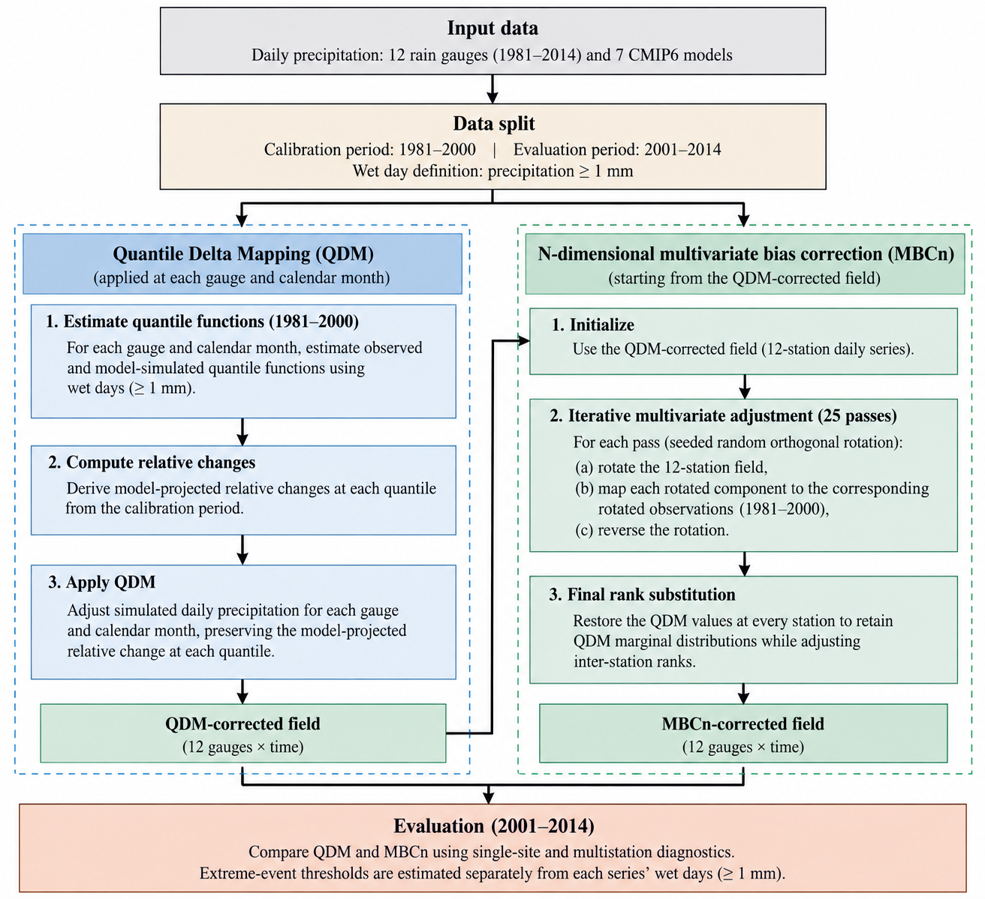
Figure 2. Revised MBCn workflow. QDM establishes station-level monthly marginal distributions; monthly-block rotation, rotated-space quantile mapping, and inverse rotation adjust the joint arrangement; final within-month rank substitution restores the QDM value set.

2.4 Single-site diagnostics
Because free-running climate simulations are not expected to reproduce the timing of individual observed rainfall events, model performance was evaluated using distributional rather than day-matched diagnostics. For each of the 84 gauge–model combinations, six complementary metrics were calculated over the independent validation period: percentage bias in total precipitation (PBIAS), wet-day-frequency error, the ratio of simulated to observed wet-day standard deviation (SD ratio), Perkins skill score (PSS), Kolmogorov–Smirnov (KS) distance, and the root mean square error (RMSE) of matched wet-day quantiles. The diagnostics were selected to assess complementary aspects of precipitation amount, occurrence, variability, distributional shape, and quantile agreement. Perkins skill score follows the probability-density-overlap approach of Perkins et al. [20].
A wet day was defined as a day with precipitation ≥1 mm. Let $O_{t}$and $M_{t}$denote observed and simulated precipitation on day $t$, respectively, and let $N$be the number of validation days. Total-precipitation bias was expressed as
$$\begin{matrix} & PBIAS=100 \frac{\sum_{t=1}^{N}{M_{t}}-\sum_{t=1}^{N}{O_{t}}}{\sum_{t=1}^{N}{O_{t}}}, & & \text{(1)}\end{matrix}$$
where values close to zero indicate smaller bias; positive and negative values indicate overestimation and underestimation, respectively.
Wet-day-frequency error was calculated in percentage points as
$$\begin{matrix} & E_{wet}=100\left(\frac{N_{M}^{wet}}{N}-\frac{N_{O}^{wet}}{N}\right), & & \text{(2)}\end{matrix}$$
where $N_{M}^{wet}$and $N_{O}^{wet}$are the numbers of simulated and observed wet days, respectively. The wet-day standard-deviation ratio was defined as
$$\begin{matrix} & R_{SD}=\frac{σ_{M}^{wet}}{σ_{O}^{wet}}, & & \text{(3)}\end{matrix}$$
where $σ_{M}^{wet}$and $σ_{O}^{wet}$are the standard deviations of simulated and observed precipitation restricted to wet days. A value of one therefore indicates agreement in wet-day variability.
To evaluate the overall distributional shape, the Perkins skill score was calculated from the simulated and observed precipitation probability distributions using common bins:
$$\begin{matrix} & PSS=\sum_{k=1}^{K}{min}\left(p_{M,k} , p_{O,k}\right), & & \text{(4)}\end{matrix}$$
where $p_{M,k}$and $p_{O,k}$are the simulated and observed probabilities in precipitation bin $k$, and $K$is the total number of common bins. PSS ranges from 0 to 1, with values closer to 1 indicating greater overlap between the two distributions. For distributional agreement based on the cumulative distribution functions (CDFs), the KS distance was calculated as
$$\begin{matrix} & D_{KS}=\sup_{x}∣F_{M}\left(x\right)-F_{O}\left(x\right)∣, & & \text{(5)}\end{matrix}$$
where $F_{M}\left(x\right)$and $F_{O}\left(x\right)$are the simulated and observed CDFs, respectively. Lower values indicate closer agreement.
Finally, agreement across the magnitude range of wet-day precipitation was evaluated using matched quantiles. For a set of quantile probabilities $p_{j}$, $j=1,…,J$, the quantile RMSE was calculated as
$$\begin{matrix} & {RMSE}_{q}=\sqrt{\frac{1}{J}\sum_{j=1}^{J}{{\left[Q_{M}\left(p_{j}\right)-Q_{O}\left(p_{j}\right)\right]}^{2}}}, & & \text{(6)}\end{matrix}$$
where $Q_{M}\left(p_{j}\right)$and $Q_{O}\left(p_{j}\right)$are the simulated and observed wet-day quantiles at probability $p_{j}$. Lower values indicate closer agreement in precipitation magnitude across the selected quantiles.
Together, these metrics provide a distribution-based assessment without requiring correspondence between simulated and observed rainfall on the same calendar day. Day-matched error measures were therefore not used, as they would confound distributional model skill with differences in the timing of weather events that free-running climate simulations are not designed to reproduce. This distribution-focused evaluation is also consistent with the use of probability distributions and precipitation-frequency characteristics in previous climate-model evaluations.

2.5 Dependence diagnostics and statistical testing
Spatial dependence was evaluated on the independent 2001–2014 validation period using primary correlation endpoints and secondary joint-distribution diagnostics. The three prespecified primary endpoints were RMSE of the inter-station Spearman correlation matrix, RMSE of the Pearson correlation matrix, and RMSE of the binary wet-day correlation matrix. Secondary diagnostics were station-standardized energy distance, normalized concurrent-q95 exceedance RMSE, an observed-threshold q95 sensitivity metric, and the Wasserstein-1 distance between daily wet-station extent distributions. All calculations used the same 12 gauges and the same validation dates available in each model record.
Let $X_{t}=\left(X_{t1} , … , X_{t12}\right)$and $Y_{t}=\left(Y_{t1} , … , Y_{t12}\right)$denote the observed and simulated 12-dimensional precipitation vectors on day $t$, respectively. Energy distance was used as a multivariate measure of overall distributional discrepancy [21]:
$$\begin{matrix} & D_{E}=2 E∥X-Y∥-E∥X-X^{'}∥-E∥Y-Y^{'}∥, & & \text{(7)}\end{matrix}$$
Energy distance was calculated after station-wise standardization by the observed calibration standard deviation, so that differences in local precipitation magnitude do not dominate the multivariate distance. A fixed-seed subsample of at most 1,500 complete validation days was used for computational control and reproducibility. The statistic is interpreted as a broad joint-distribution discrepancy rather than as a pure correlation coefficient.
Dependence among stations was further evaluated from the three $12×12$correlation matrices: Spearman rank correlation, Pearson correlation, and binary wet-day correlation. Because the diagonal elements represent self-correlations and do not contain information about inter-station dependence, only the 66 unique off-diagonal station pairs were evaluated. For a given correlation measure $r$, the corresponding matrix RMSE was calculated as
$$\begin{matrix} & {RMSE}_{r}={\left[\frac{1}{66}\sum_{i<j}{{\left(r_{ij}^{M}-r_{ij}^{O}\right)}^{2}}\right]}^{1/2}, & & \text{(8)}\end{matrix}$$
where $r_{ij}^{M}$and $r_{ij}^{O}$denote the simulated and observed correlations for station pair $\left(i , j\right)$, respectively. For the wet-day correlation, precipitation at each station was converted to a binary indicator
$$\begin{matrix} & W_{ti}=\left\{\begin{matrix}1, & P_{ti}≥1 mm, \\ 0, & P_{ti}<1 mm,\end{matrix}\right. & & \text{(9)}\end{matrix}$$
consistent with the wet-day definition used throughout the analysis. The resulting binary series were then used to calculate pairwise correlations. The three correlation-based RMSEs were treated as the prespecified primary dependence endpoints, consistent with the statistical testing framework of the study.
Concurrent precipitation extremes were evaluated in two ways. The primary dependence-focused metric uses each station's own method-specific 95th wet-day percentile and normalizes the observed and simulated joint exceedance probability by the corresponding marginal exceedance probabilities. This reduces sensitivity to residual differences in individual-station extreme frequency. A second sensitivity metric uses the observed station-specific 95th wet-day thresholds for all methods and is interpreted as a hazard-oriented measure. The two metrics are reported separately because they answer different scientific questions.
$$\begin{matrix} & J_{ij}=\frac{1}{N}\sum_{t=1}^{N}{I}\left(P_{ti}>q_{i,0.95}\right)I\left(P_{tj}>q_{j,0.95}\right), & & \text{(10)}\end{matrix}$$
where $q_{i,0.95}$and $q_{j,0.95}$are the station-specific 95th percentiles of wet-day precipitation and $I\left(⋅\right)$is the indicator function. The corresponding discrepancy was summarized over the 66 station pairs as
$$\begin{matrix} & {RMSE}_{J}={\left[\frac{1}{66}\sum_{i<j}{{\left(J_{ij}^{M}-J_{ij}^{O}\right)}^{2}}\right]}^{1/2}. & & \text{(11)}\end{matrix}$$
This metric evaluates whether the correction method reproduces the spatial occurrence of concurrent heavy precipitation rather than the frequency of extreme precipitation at individual stations. The use of each station's own 95th wet-day percentile follows the study design and minimizes the influence of residual marginal differences on the dependence assessment.
At the network scale, the spatial extent of daily wet conditions was represented by the number of stations recording precipitation of at least 1 mm on each day,
$$\begin{matrix} & H_{t}=\sum_{i=1}^{12}{I}\left(P_{ti}≥1 mm\right). & & \text{(12)}\end{matrix}$$
The distributions of $H_{t}$from the simulations and observations were compared using the Wasserstein-1 distance,
$$\begin{matrix} & W_{1}\left(F_{M} , F_{O}\right)=\int_{-∞}^{∞}{∣F_{M}\left(h\right)-F_{O}\left(h\right)∣} dh, & & \text{(13)}\end{matrix}$$
where $F_{M}$and $F_{O}$are the empirical cumulative distribution functions of daily wet-station extent for the simulated and observed fields, respectively. Lower values indicate closer agreement in the spatial coverage of wet conditions. This network-scale metric complements the pairwise joint-exceedance measure by evaluating the overall distribution of wet-station extent rather than the identity of particular station pairs.
All dependence diagnostics are negatively oriented, so smaller values indicate closer agreement with observations. Seven model-level scores were retained separately and then compared as matched pairs between QDM and MBCn. The seven GCMs are not treated as a random sample from a population of climate models; the paired tests therefore describe consistency within this specified ensemble rather than population-level inference.
For formal comparison, the seven model-level scores from MBCn and QDM were treated as matched observations. For each diagnostic, the paired difference was defined as
$$\begin{matrix} & d_{m}=S_{m}^{QDM}-S_{m}^{MBCn}, m=1,…,7, & & \text{(14)}\end{matrix}$$
so that $d_{m}>0$indicates an improvement with MBCn because all dependence diagnostics are negatively oriented. A one-sided exact Wilcoxon signed-rank test was then applied to the seven paired differences. The analysis tests whether the observed within-ensemble differences consistently favour MBCn; it is not intended to provide inference to a broader population of climate models. The strength and direction of the paired effect were additionally summarized using the matched-pairs rank-biserial correlation,
$$\begin{matrix} & r_{rb}=\frac{W^{+}-W^{-}}{W^{+}+W^{-}}, & & \text{(15)}\end{matrix}$$
where $W^{+}$and $W^{-}$are the sums of the positive and negative signed ranks, respectively. Values approaching $+1$indicate that the paired differences consistently favour MBCn under the definition in Eq. (14). The number of models for which MBCn produced the lower diagnostic value was also reported to make the direction of the model-level comparison explicit. In the present seven-model ensemble, this paired framework yielded a maximum possible rank-biserial effect size when all models favoured MBCn.
Because Spearman, Pearson, and wet-day-correlation RMSE were specified a priori as the primary correlation endpoints, their $p$-values were adjusted for multiple testing using the Holm–Bonferroni procedure. If $p_{\left(1\right)}≤⋯≤p_{\left(m\right)}$are the ordered $mp$-values, the adjusted values are obtained sequentially as
$$\begin{matrix} & p_{\left(i\right)}^{ adj}=\min\left[1 , \max_{k≤i}\left\{\left(m-k+1\right)p_{\left(k\right)}\right\}\right]. & & \text{(16)}\end{matrix}$$
Because Spearman, Pearson, and wet-day-correlation RMSE were prespecified as the primary correlation endpoints, their one-sided p-values were adjusted within this three-test family using Holm–Bonferroni. Standardized energy distance, normalized joint-q95 RMSE, observed-threshold q95 RMSE, and wet-extent W₁ were treated as secondary or sensitivity diagnostics. This hierarchy avoids treating correlated dependence metrics as independent confirmatory tests.

2.6 Robustness checks
Robustness was assessed using an iteration sweep from 0 to 100 passes, with zero passes representing QDM, and a random-seed sensitivity experiment using 20 seeds on the three prespecified GCMs (ACCESS-ESM1-5, MIROC6, and MRI-ESM2-0). The production configuration of 25 passes and seed 42 was fixed a priori and was not selected by minimizing validation error. Temporal structure was additionally evaluated using occurrence autocorrelation at lags 1, 3, 7, and 30 days, wet-to-wet and dry-to-dry transition probabilities, mean annual CDD and CWD, and mean annual Rx5day. Seasonal dependence was evaluated separately for DJF, MAM, JJA, and SON.
The preservation of the model-projected precipitation-change signal was assessed using five selected wet-day precipitation quantiles. For each gauge, climate model, pathway, future period, and quantile $p$, the projected percentage change was calculated as
$$\begin{matrix} & ΔQ_{p}=100\left(\frac{Q_{p,f}-Q_{p,b}}{Q_{p,b}}\right), & & \text{(17)}\end{matrix}$$
where $Q_{p,b}$and $Q_{p,f}$denote the $p$-th wet-day precipitation quantiles during the baseline and future periods, respectively.
The deviation of the bias-corrected change signal from the corresponding raw model signal was quantified using the mean absolute deviation (MAD):
$$\begin{matrix} & MAD=\frac{1}{N}\sum_{i=1}^{N}{∣ΔQ_{p,i}^{C}-ΔQ_{p,i}^{R}∣}, & & \text{(18)}\end{matrix}$$
where $ΔQ_{p,i}^{C}$and $ΔQ_{p,i}^{R}$are the projected percentage changes after bias correction and from the raw climate-model output, respectively, and $N$is the total number of gauge–model–pathway–period–quantile combinations.
Agreement between the corrected and raw projected changes was additionally quantified using the coefficient of determination:
$$\begin{matrix} & R^{2}=1-\frac{\sum_{i=1}^{N}{{\left(ΔQ_{p,i}^{C}-ΔQ_{p,i}^{R}\right)}^{2}}}{\sum_{i=1}^{N}{{\left(ΔQ_{p,i}^{R}-\overset{‾}{ΔQ_{p}^{R}}\right)}^{2}}}, & & \text{(19)}\end{matrix}$$
where $\overset{‾}{ΔQ_{p}^{R}}$is the mean raw projected percentage change across all comparison cases.
These robustness analyses assess numerical stability, sensitivity to stochastic initialization, temporal consequences, seasonal dependence, and preservation of the model-projected precipitation-change signal. They do not constitute validation of future climate projections against observations.

3. Results and Discussion

3.1 Single-site performance is identical between the two corrections
The independent validation confirms the station-level behaviour expected from the revised implementation. Across 84 gauge–model combinations, the raw model output had mean PBIAS of 1.39 ± 34.71%, wet-day-frequency error of 10.56 ± 17.24 percentage points, wet-day SD ratio of 0.686 ± 0.491, PSS of 0.824 ± 0.099, KS distance of 0.221 ± 0.104, and wet-day quantile RMSE of 7.83 ± 4.16 mm d⁻¹. QDM reduced the KS distance to 0.101 ± 0.060 and increased PSS to 0.915 ± 0.053; wet-day SD ratio approached unity at 0.985 ± 0.361. Residual total-precipitation and occurrence biases remained, with PBIAS of −17.15 ± 20.82% and wet-day-frequency error of −6.35 ± 12.30 percentage points.
QDM and MBCn produced identical values for all six station-level validation diagnostics to the numerical precision of the analysis. This follows from the final within-month rank-substitution step, which restores the QDM value set at each station. The equality should therefore be interpreted as a property of the algorithmic construction rather than as evidence that the two methods produce identical multistation fields.

Method | PBIAS (%) | Wet-day frequency error (pp) | SD ratio (–) | PSS (–) | KS distance (–) | Quantile RMSE (mm d⁻¹)
RAW | 1.39 ± 34.71 | 10.56 ± 17.24 | 0.686 ± 0.491 | 0.824 ± 0.099 | 0.221 ± 0.104 | 7.83 ± 4.16
QDM | −17.15 ± 20.82 | −6.35 ± 12.30 | 0.985 ± 0.361 | 0.915 ± 0.053 | 0.101 ± 0.060 | 4.08 ± 3.05
MBCn | −17.15 ± 20.82 | −6.35 ± 12.30 | 0.985 ± 0.361 | 0.915 ± 0.053 | 0.101 ± 0.060 | 4.08 ± 3.05
Table 3. Station-level skill over the withheld validation period (mean ± SD, n = 84 gauge–model pairs). QDM and MBCn are identical because the revised MBCn implementation restores the QDM value set within each calendar month.
pp = percentage points; PSS = Perkins skill score; KS = Kolmogorov–Smirnov; SD ratio is the corrected-to-observed ratio of the wet-day standard deviation. QDM and MBCn coincide on every score because MBCn reinstates the QDM value at each gauge.
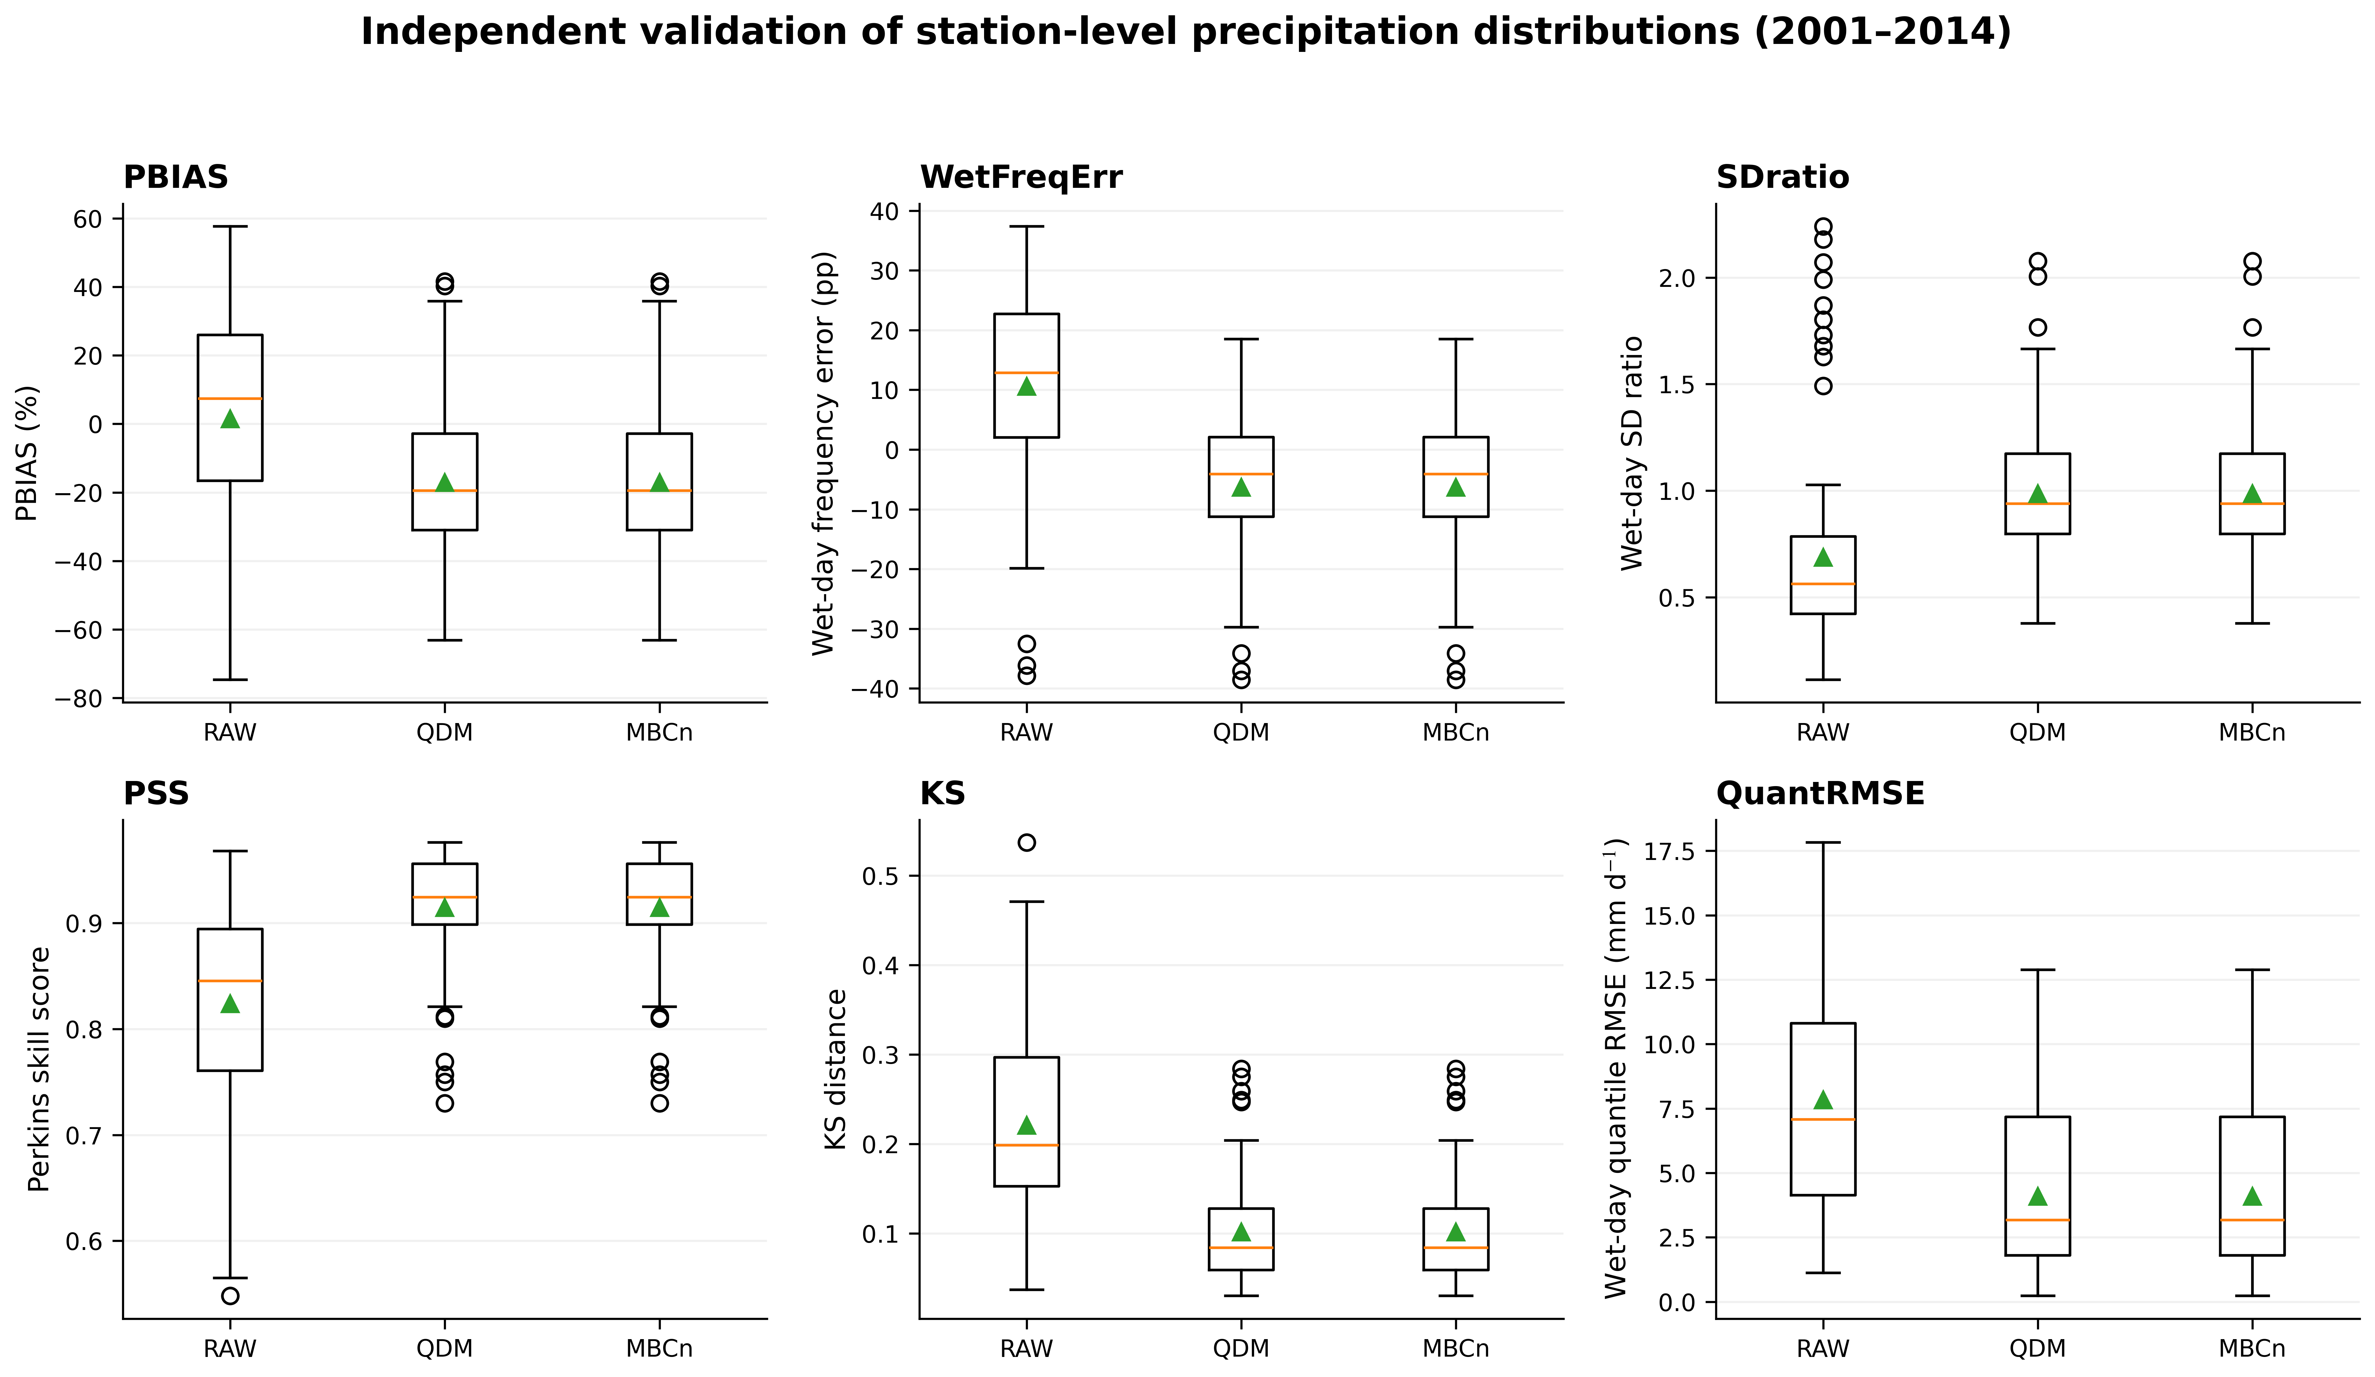
Figure 3. Independent validation of station-level precipitation distributions for RAW, QDM, and MBCn over 2001–2014 (n = 84 gauge–model pairs).

3.2 MBCn improves inter-station dependence consistently across models
MBCn substantially improved the principal inter-station dependence measures relative to QDM (Table 4). The seven-model mean standardized energy distance decreased from 0.139 to 0.104, corresponding to a 25.5% reduction. Spearman correlation-matrix RMSE decreased from 0.286 to 0.157 (45.1%), Pearson RMSE from 0.374 to 0.124 (66.8%), and wet-day occurrence RMSE from 0.273 to 0.111 (59.2%). Normalized joint-q95 RMSE decreased from 0.00542 to 0.00256 (52.7%), and wet-extent W₁ decreased from 0.107 to 0.069 (35.3%).
All seven GCMs favoured MBCn for the three primary correlation endpoints, standardized energy distance, normalized joint-q95 RMSE, and wet-extent W₁. The one-sided exact Wilcoxon signed-rank test yielded W = 28.0 and p = 0.0078 for each primary endpoint; Holm-adjusted p = 0.0234. The matched-pairs rank-biserial effect size was 1.00 in each case. These statistics indicate unanimous within-ensemble direction, not inference to an external population of GCMs.
The observed-threshold q95 sensitivity metric showed a more nuanced result: its seven-model mean decreased from 0.00497 under QDM to 0.00292 under MBCn, but MBCn was better in six of seven models rather than seven of seven. This distinction is important because the observed-threshold metric is more directly influenced by the absolute frequency of events exceeding an observed hazard threshold, whereas the normalized metric is designed to isolate dependence structure.
The distance-decay analysis shows that raw CMIP6 precipitation is excessively coherent across the gauge network, while QDM reduces but does not eliminate this bias. MBCn produces the closest overall agreement with the observed decline of Spearman correlation with gauge separation. The 66 station pairs are not independent sampling units, so the distance-decay and pair-bootstrap results are interpreted descriptively rather than as independent hypothesis tests.

Method | Std. energy distance | Spearman RMSE | Pearson RMSE | Wet-occurrence RMSE | Joint q95 RMSE | Wet-extent W₁
RAW | 0.169 | 0.484 | 0.488 | 0.476 | 0.0150 | 0.174
QDM | 0.139 | 0.286 | 0.374 | 0.273 | 0.00542 | 0.107
MBCn | 0.104 | 0.157 | 0.124 | 0.111 | 0.00256 | 0.069
Table 4. Dependence diagnostics against observations (seven-model mean, independent 2001–2014 validation). Lower values indicate closer agreement. Energy distance is station-standardized and dimensionless. Joint q95 RMSE in this table is the normalized dependence-focused definition; an observed-threshold sensitivity result is reported separately in the text.
Values are means of per-model scores. The energy distance is the broadest whole-distribution measure, computed on a fixed-seed random subsample of at most 1,500 days; the correlation-matrix RMSEs, the joint-exceedance RMSE and the wet-extent Wasserstein-1 distance (W₁) are structure diagnostics. Joint exceedance uses each series' own wet-day ninety-fifth percentile and wet extent the 1 mm threshold. MBCn is closest to observations on every diagnostic. All quantities are dimensionless.

Diagnostic | Models favouring MBCn | W | p | Holm-adjusted p | Effect size
Std. energy distance (secondary) | 7/7 | 28.0 | 0.0078 | – | 1.00
Spearman RMSE (primary) | 7/7 | 28.0 | 0.0078 | 0.0234 | 1.00
Pearson RMSE (primary) | 7/7 | 28.0 | 0.0078 | 0.0234 | 1.00
Wet-day co-occurrence RMSE (primary) | 7/7 | 28.0 | 0.0078 | 0.0234 | 1.00
Normalized joint q95 RMSE (secondary) | 7/7 | 28.0 | 0.0078 | – | 1.00
Observed-threshold q95 RMSE (sensitivity) | 6/7 | 27.0 | 0.0156 | – | 0.93
Wet-extent W₁ (secondary) | 7/7 | 28.0 | 0.0078 | – | 1.00
Table 5. Paired comparison of MBCn against QDM across the seven GCMs using one-sided exact Wilcoxon signed-rank tests. Holm–Bonferroni adjustment is applied only to the three prespecified primary correlation endpoints.
Every model improves under MBCn on every diagnostic, yielding the maximum matched-pairs rank-biserial effect size and the smallest p attainable at n = 7. The Holm adjustment covers the three pre-declared correlation endpoints; the remaining diagnostics are exploratory and reported unadjusted.
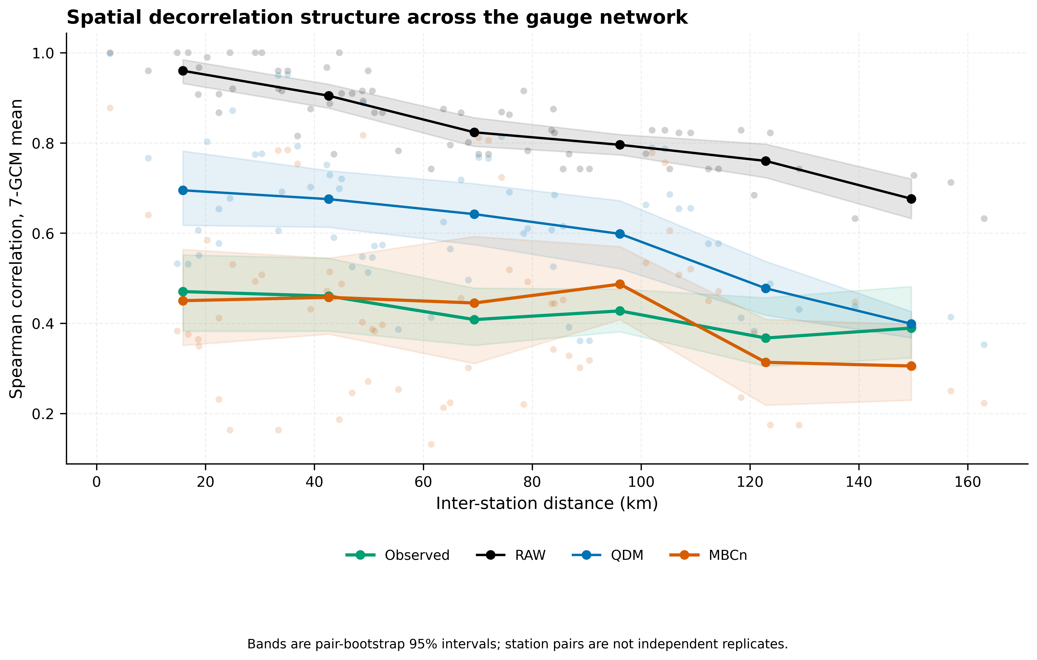
Figure 4. Inter-station Spearman correlation versus gauge separation. MBCn provides the closest overall agreement with the observed distance-decay relationship.

3.3 Spatial organisation of concurrent extremes
The concurrent-extreme analysis supports the dependence result but also demonstrates why the two q95 definitions must be separated. Using the normalized station-specific q95 definition, pooled validation RMSE was approximately 0.0134 for raw output, 0.00446 for QDM, and 0.00235 for MBCn. Under the observed-threshold sensitivity definition, the corresponding pooled RMSE values were approximately 0.00514, 0.00381, and 0.00237. MBCn therefore provides the clearest improvement in dependence-focused concurrent extremes, while the hazard-oriented metric shows a smaller and model-dependent advantage.
The network-scale wet-station extent also improved under MBCn. The seven-model mean Wasserstein-1 distance was 0.174 for raw output, 0.107 for QDM, and 0.069 for MBCn. The widespread-event analysis provides a consistent network-scale interpretation: for events affecting at least six of the 12 gauges, observed frequency was 1.93 days yr⁻¹, compared with 3.61 for raw output, 3.55 for QDM, and 1.30 for MBCn. MBCn therefore reduced the excessive frequency of the most spatially extensive events more effectively than QDM, although the corrected frequency remained slightly below the observed value.
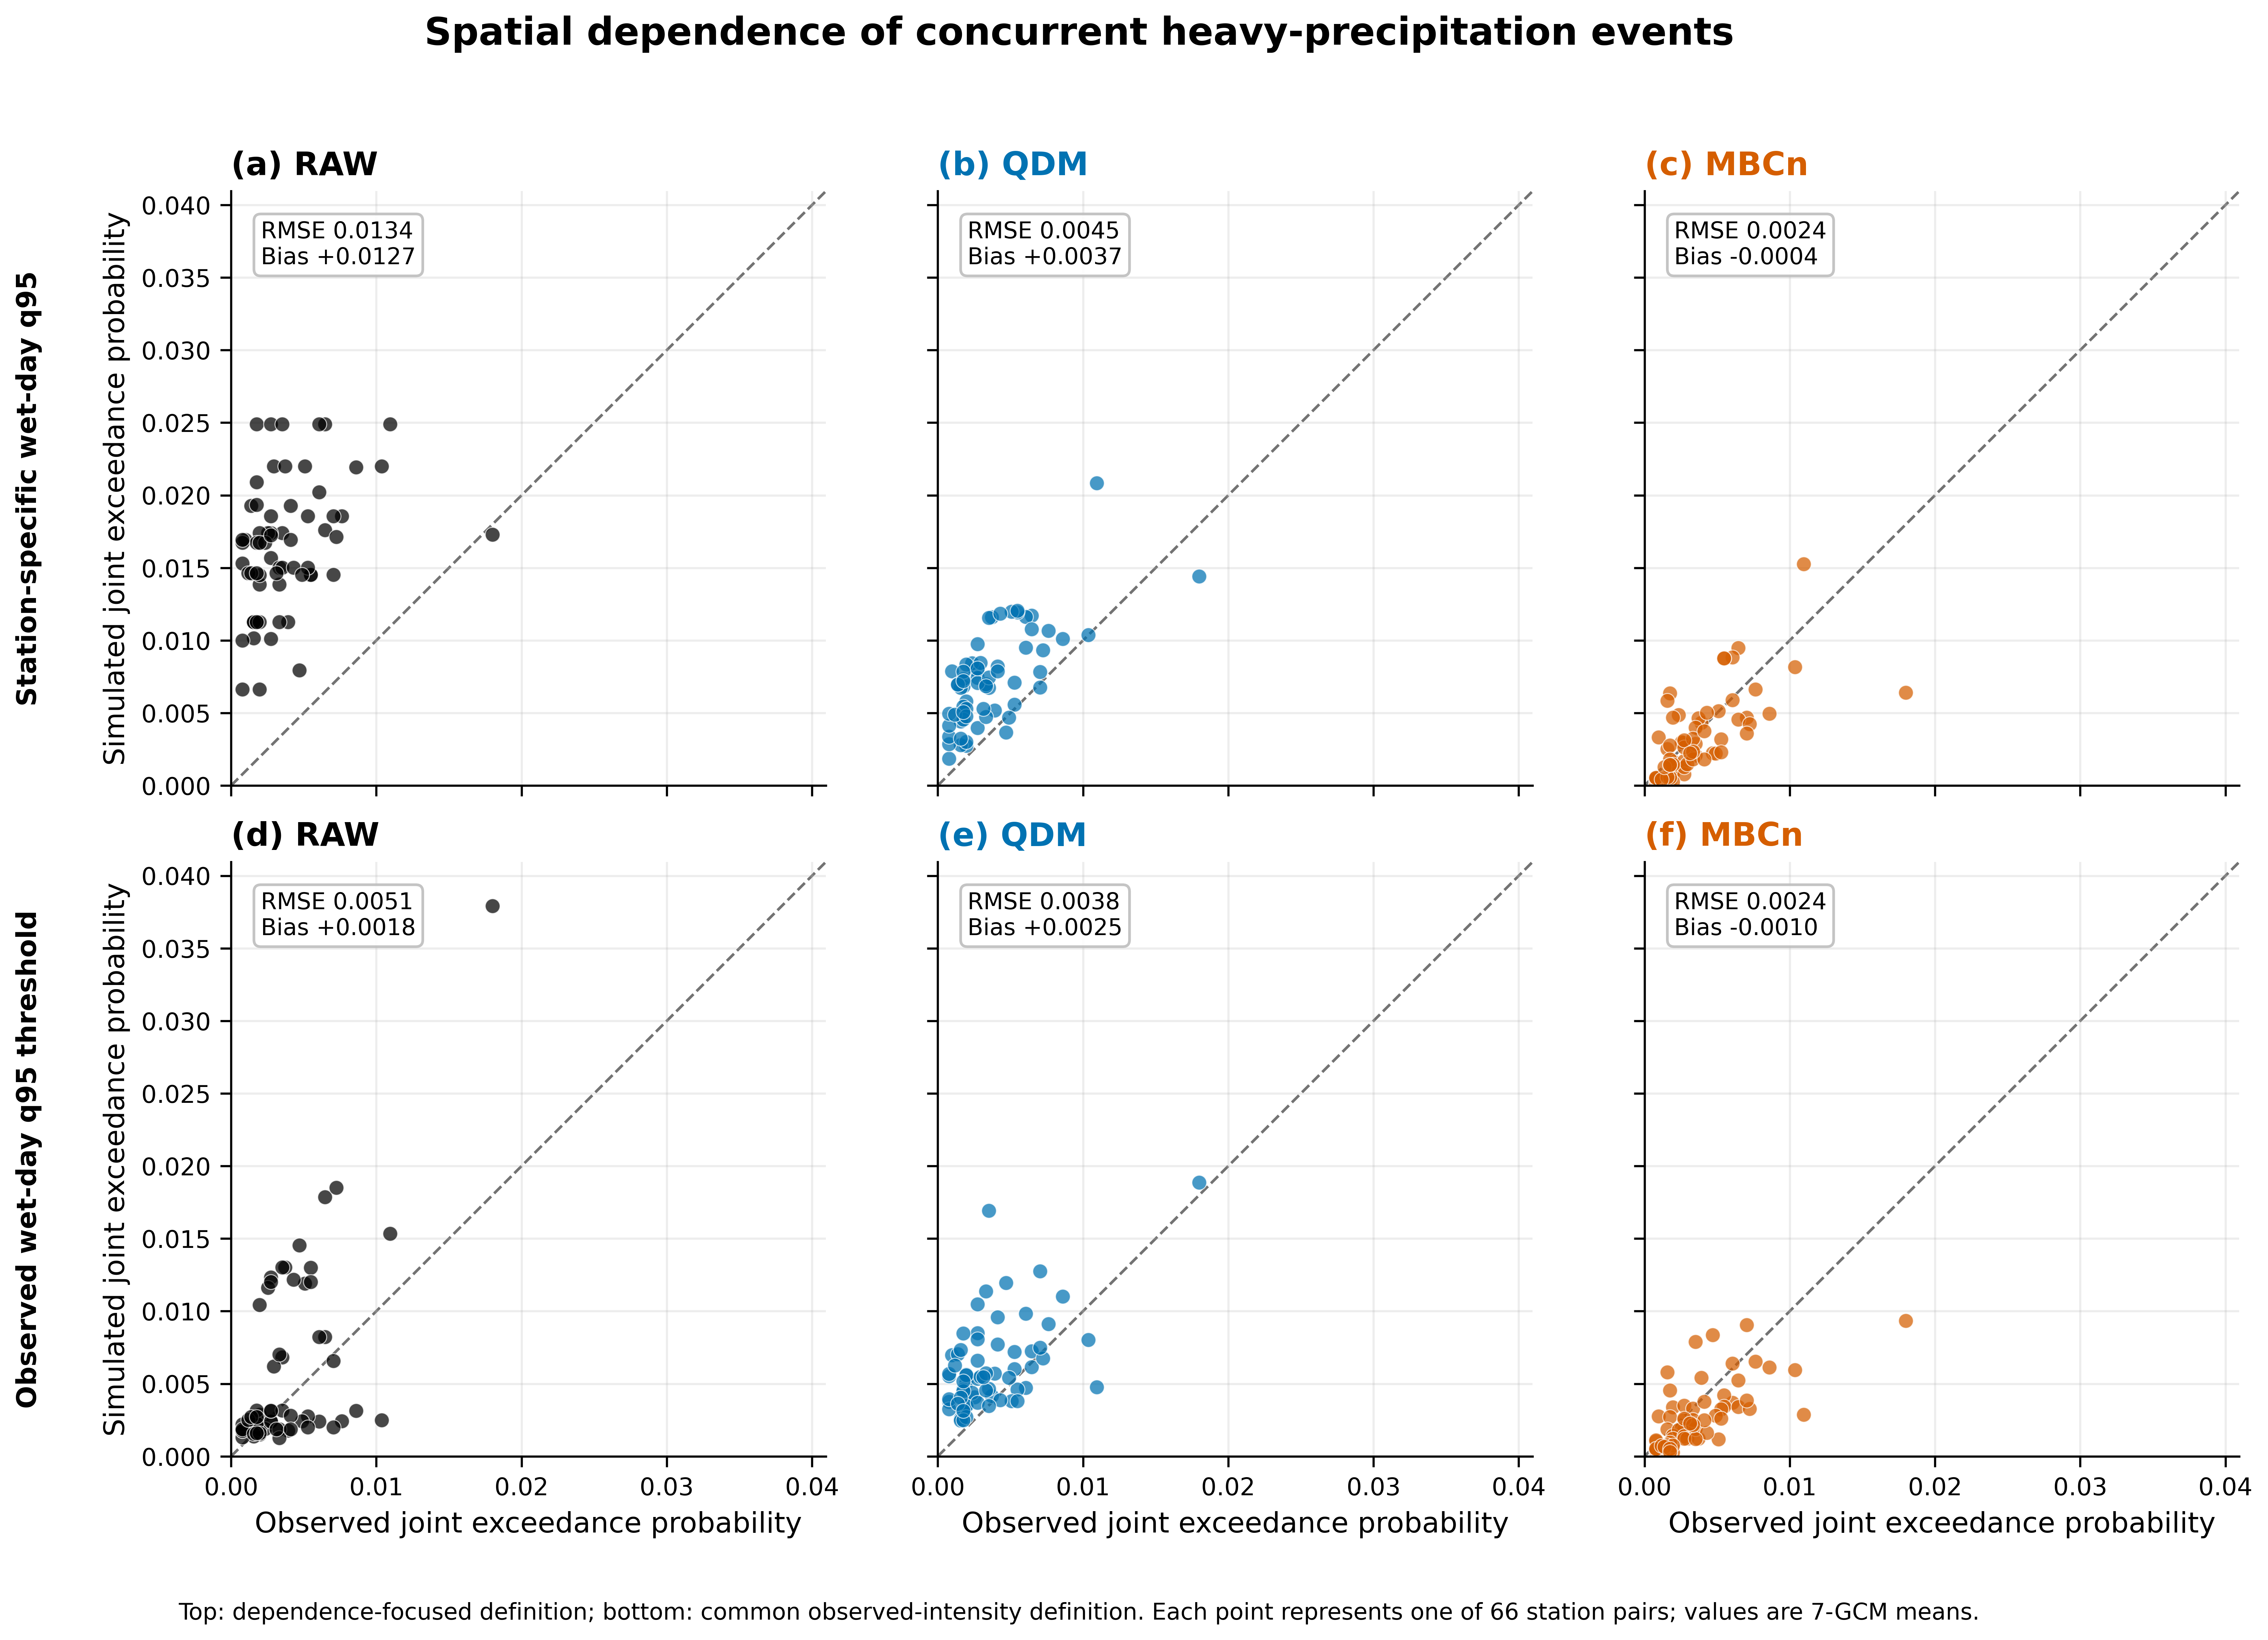
Figure 5. Pairwise concurrent-exceedance probabilities. The upper row uses the normalized station-specific q95 definition for dependence assessment; the lower row uses observed q95 thresholds as a hazard-oriented sensitivity analysis.

3.4 Numerical behaviour and fidelity to the projected change signal
The iteration sweep did not show a monotonic improvement with increasing passes. Across the three prespecified GCMs, the mean Spearman RMSE fell from 0.276 at zero passes to 0.152 at five passes and 0.149 at ten passes, then oscillated around 0.156–0.164 through 15–100 passes. Mean wet-day occurrence RMSE declined from 0.254 at zero passes to 0.106 at five passes and 0.103 at ten passes, followed by modest oscillations. Thus, most of the dependence adjustment occurred within approximately 5–10 passes. The production value of 25 passes was retained because it was fixed a priori; it should not be described as the empirically optimal iteration count.
Seed sensitivity showed relatively small variability in the primary correlation diagnostics. Across 20 seeds and the three prespecified GCMs, the coefficient of variation was 5.9% for Spearman RMSE and 11.8% for wet-day occurrence RMSE. At the individual-GCM level, mean Spearman RMSE across seeds was 0.152 for ACCESS-ESM1-5, 0.153 for MIROC6, and 0.170 for MRI-ESM2-0. The corresponding wet-occurrence RMSE values were 0.094, 0.110, and 0.124. These results indicate stochastic sensitivity that is modest relative to the QDM-to-MBCn improvement, while also showing that seed dependence should not be assumed to be negligible.
Future signal preservation was evaluated primarily against the method-consistent 1981–2000 baseline. Across the 2,520 gauge–model–scenario–period–quantile cases, mean absolute deviation from the raw model projected change signal was 10.32 percentage points for QDM and 9.66 percentage points for MBCn. For SSP2-4.5 the corresponding MAE values were 8.66 and 8.09 percentage points; for SSP5-8.5 they were 11.97 and 11.23 percentage points. The mean correlations between corrected and raw change signals were 0.687 for QDM and 0.654 for MBCn. MBCn therefore did not introduce a large additional loss of projected quantile-change fidelity, but neither method should be characterized as reproducing the raw signal exactly.
Temporal diagnostics reveal an important trade-off. Relative to observations, MBCn had lower mean absolute error than QDM for lag-1 occurrence autocorrelation (0.072 vs 0.156), lag-3 (0.057 vs 0.075), and lag-30 (0.039 vs 0.054), but it altered persistence-related quantities. Mean absolute error for CWD was 18.0 days for MBCn versus 14.6 days for QDM, while Rx5day error was 25.1 mm versus 23.2 mm. Wet-to-wet transition error was also larger for MBCn (0.117 vs 0.053), whereas dry-to-dry transition error was similar (0.029 vs 0.025). Seasonally, MBCn reduced Spearman and wet-occurrence RMSE in all four seasons; the largest Spearman improvement occurred in JJA, from 0.501 under QDM to 0.183 under MBCn. Normalized joint-q95 RMSE improved in DJF and JJA, changed little in MAM, and improved in SON. These results demonstrate that spatial dependence correction and temporal-sequence preservation are distinct objectives.
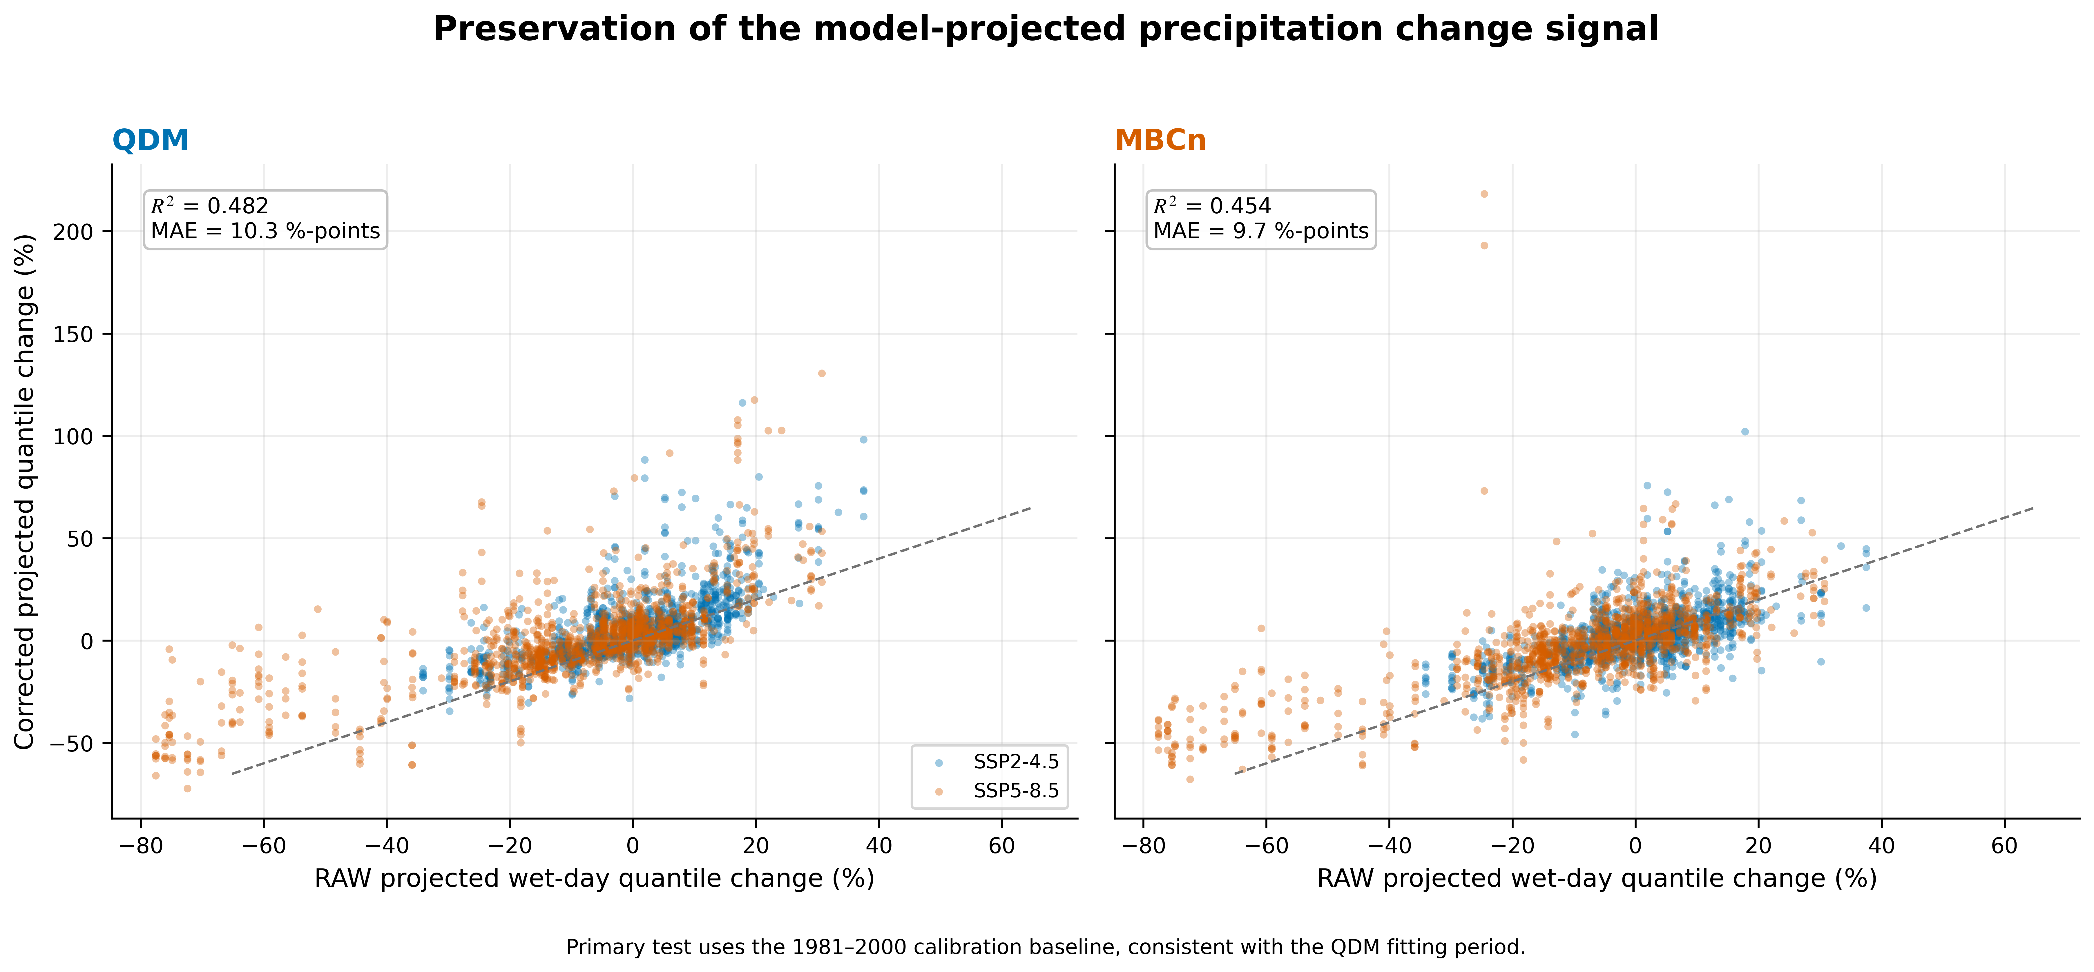
Figure 6. Raw versus corrected projected changes in wet-day precipitation quantiles using the 1981–2000 method-consistent baseline. QDM and MBCn show broadly comparable fidelity to the raw model change signal.

3.5 Implications and limitations
The evidence supports a context-specific choice rather than a universal ranking. QDM is computationally simpler and remains appropriate when the scientific target is station-level marginal distributions and projected quantile changes. MBCn provides substantially better agreement in the spatial dependence structure of this 12-gauge coastal network, making it better supported for distributed hydrological modelling, spatial hazard mapping, and multivariate risk analysis. However, the temporal diagnostics show that MBCn can alter wet/dry persistence and Rx5day, so spatial dependence improvement should not be treated as universal improvement in rainfall sequence characteristics.
A central methodological implication is that marginal validation alone cannot distinguish QDM from the present MBCn formulation, because MBCn restores the QDM marginal value set within calendar-month blocks. Dependence diagnostics are therefore necessary whenever multiple corrected gauges will be analysed jointly. Conversely, temporal diagnostics are necessary whenever corrected daily sequences will be used for spell, persistence, or multi-day extreme analyses.
Five limitations constrain generalization. First, one realization per GCM does not represent internal variability. Second, the study uses a single coastal gauge network and may not represent inland or other monsoon regimes. Third, the stationary historical dependence target may not remain appropriate under future climate. Fourth, residual marginal biases remain after correction, including a mean total-precipitation bias of about −17% and a wet-day-frequency bias of about −6 percentage points. Fifth, the seven-model ensemble is a matched set rather than a random population, so the paired Wilcoxon results describe within-ensemble consistency. Finally, MBCn's spatial gains must be interpreted together with its temporal and seasonal effects.

4. Conclusion
Across 12 Prachuap Khiri Khan rain gauges and seven CMIP6 models, the revised station-locked monthly-block analysis shows a clear separation between marginal and joint performance. QDM and MBCn are identical for the six station-level validation diagnostics by construction, whereas MBCn substantially reduces inter-station dependence errors: 45.1% for Spearman RMSE, 66.8% for Pearson RMSE, 59.2% for wet-day occurrence RMSE, and 52.7% for normalized joint-q95 RMSE relative to QDM. All seven models favour MBCn for the three prespecified primary endpoints, with exact one-sided p = 0.0078 and Holm-adjusted p = 0.0234. Nevertheless, MBCn does not improve every rainfall property: temporal diagnostics show changes in wet/dry persistence and Rx5day, and the observed-threshold q95 sensitivity metric favours MBCn in six of seven models. Future projected wet-day quantile-change fidelity remains broadly comparable between methods. QDM is therefore appropriate when marginal fidelity is sufficient, while MBCn is better supported when inter-station dependence is an explicit requirement, provided that temporal and seasonal consequences are evaluated before downstream hydrological use.

Acknowledgment
The author gratefully acknowledges the Thai Meteorological Department (TMD) for providing observed daily precipitation records.

Author Contributions
Surasit Punyawansiri: conceptualization, methodology, software, validation, formal analysis, investigation, resources, data curation, writing - original draft, writing - review and editing, visualization, supervision, and project administration. The author has read and approved the submitted manuscript.

Funding
This research received no external funding.

Conflicts of Interest
The author declares no conflict of interest.

Data and Code Availability
The daily rain-gauge records are available from the Thai Meteorological Department (TMD) subject to its data-sharing conditions. CMIP6 output is publicly available through the Earth System Grid Federation. Analysis code and underlying numerical data for the figures are available from the corresponding author on reasonable request.
Reproducibility note. The numerical results in this manuscript were regenerated from the supplied Prachuap Khiri Khan data archive using the Q2.1 station-locked monthly-block MBCn pipeline. The source archive contains additional stations and precomputed bc_pr_day files; the primary manuscript analysis does not use those precomputed corrected files. QDM and MBCn results reported here are generated directly from the raw historical CMIP6 series using the same 1981–2000 calibration period and the same 12-station network.

References
[1] D. Maraun, "Bias correcting climate change simulations - a critical review," Curr. Clim. Change Rep., vol. 2, no. 4, pp. 211-220, 2016, doi: 10.1007/s40641-016-0050-x.
[2] C. Teutschbein and J. Seibert, "Bias correction of regional climate model simulations for hydrological climate-change impact studies: Review and evaluation of different methods," J. Hydrol., vols. 456-457, pp. 12-29, 2012, doi: 10.1016/j.jhydrol.2012.05.052.
[3] L. Gudmundsson, J. B. Bremnes, J. E. Haugen, and T. Engen-Skaugen, "Technical Note: Downscaling RCM precipitation to the station scale using statistical transformations - a comparison of methods," Hydrol. Earth Syst. Sci., vol. 16, no. 9, pp. 3383-3390, 2012, doi: 10.5194/hess-16-3383-2012.
[4] A. J. Cannon, S. R. Sobie, and T. Q. Murdock, "Bias correction of GCM precipitation by quantile mapping: How well do methods preserve changes in quantiles and extremes?" J. Clim., vol. 28, no. 17, pp. 6938-6959, 2015, doi: 10.1175/JCLI-D-14-00754.1.
[5] E. Bevacqua et al., "Advancing research on compound weather and climate events via large ensemble model simulations," Nat. Commun., vol. 14, Art. no. 2145, 2023, doi: 10.1038/s41467-023-37847-5.
[6] M. Vrac, "Multivariate bias adjustment of high-dimensional climate simulations: The Rank Resampling for Distributions and Dependences (R2D2) bias correction," Hydrol. Earth Syst. Sci., vol. 22, no. 6, pp. 3175-3196, 2018, doi: 10.5194/hess-22-3175-2018.
[7] Y. Robin, M. Vrac, P. Naveau, and P. Yiou, "Multivariate stochastic bias corrections with optimal transport," Hydrol. Earth Syst. Sci., vol. 23, no. 2, pp. 773-786, 2019, doi: 10.5194/hess-23-773-2019.
[8] A. J. Cannon, "Multivariate quantile mapping bias correction: An N-dimensional probability density function transform for climate model simulations of multiple variables," Clim. Dyn., vol. 50, nos. 1-2, pp. 31-49, 2018, doi: 10.1007/s00382-017-3580-6.
[9] B. François, M. Vrac, A. J. Cannon, Y. Robin, and D. Allard, "Multivariate bias corrections of climate simulations: Which benefits for which losses?" Earth Syst. Dyn., vol. 11, no. 2, pp. 537-562, 2020, doi: 10.5194/esd-11-537-2020.
[10] D. Dieng et al., "Multivariate bias-correction of high-resolution regional climate change simulations for West Africa: Performance and climate change implications," J. Geophys. Res. Atmos., vol. 127, no. 8, Art. no. e2021JD034836, 2022, doi: 10.1029/2021JD034836.
[11] S. I. Seneviratne et al., "Weather and climate extreme events in a changing climate," in Climate Change 2021: The Physical Science Basis, Cambridge, U.K.: Cambridge Univ. Press, 2021, pp. 1513-1766, doi: 10.1017/9781009157896.013.
[12] S. Supharatid, J. Nafung, and T. Aribarg, "Projected changes in temperature and precipitation over mainland Southeast Asia by CMIP6 models," J. Water Clim. Change, vol. 13, no. 1, pp. 337-356, 2022, doi: 10.2166/wcc.2021.015.
[13] X. Qin and C. Dai, "Comparison of different quantile delta mapping schemes in frequency analysis of precipitation extremes over mainland Southeast Asia under climate change," J. Hydrol., vol. 606, Art. no. 127421, 2022, doi: 10.1016/j.jhydrol.2021.127421.
[14] S. Try and X. Qin, "Evaluation of future changes in climate extremes over Southeast Asia using downscaled CMIP6 GCM projections," Water, vol. 16, no. 15, Art. no. 2207, 2024, doi: 10.3390/w16152207.
[15] U. W. Humphries, M. Waqas, P. T. Hlaing, P. Dechpichai, and A. Wangwongchai, "Assessment of CMIP6 GCMs for selecting a suitable climate model for precipitation projections in Southern Thailand," Results Eng., vol. 23, Art. no. 102417, 2024, doi: 10.1016/j.rineng.2024.102417.
[16] S. Rojpratak and S. Supharatid, "Regional extreme precipitation index: Evaluations and projections from the multi-model ensemble CMIP5 over Thailand," Weather Clim. Extremes, vol. 37, Art. no. 100475, 2022, doi: 10.1016/j.wace.2022.100475.
[17] D. Khadka, M. S. Babel, M. Collins, S. Shrestha, S. G. P. Virdis, and A. S. Chen, "Projected changes in the near-future mean climate and extreme climate events in Northeast Thailand," Int. J. Climatol., vol. 42, no. 4, pp. 2470-2492, 2022, doi: 10.1002/joc.7377.
[18] D. Kuinkel, P. Promchote, K. R. Upreti, S.-Y. Wang, N. Dahal, and B. Pokharel, "Projected changes in precipitation extremes in Southern Thailand using CMIP6 models," Theor. Appl. Climatol., vol. 155, no. 9, pp. 8703-8716, 2024, doi: 10.1007/s00704-024-05150-y.
[19] Y. H. Song and E.-S. Chung, "Comparison of quantile mapping methods for daily precipitation correction and future projections under the SSP5-8.5," J. Korea Water Resour. Assoc., vol. 57, no. 12, pp. 1069-1083, 2024, doi: 10.3741/JKWRA.2024.57.12.1069.
[20] S. E. Perkins, A. J. Pitman, N. J. Holbrook, and J. McAneney, "Evaluation of the AR4 climate models' simulated daily maximum temperature, minimum temperature, and precipitation over Australia using probability density functions," J. Clim., vol. 20, no. 17, pp. 4356-4376, 2007, doi: 10.1175/JCLI4253.1.
[21] G. J. Székely and M. L. Rizzo, "Energy statistics: A class of statistics based on distances," J. Stat. Plan. Inference, vol. 143, no. 8, pp. 1249-1272, 2013, doi: 10.1016/j.jspi.2013.03.018.
[22] S. Sharma, A. S. Raghuvanshi, and A. Agarwal, "Evaluating the performance of uni- and multivariate bias correction techniques: Challenges in preserving temporal and dependence structures," Water Resour. Res., vol. 62, no. 2, Art. no. e2025WR041526, 2026, doi: 10.1029/2025WR041526.
[23] K. Tedprasith and W. Lohpaisankrit, "Development of intensity-duration-frequency relationships in Khon Kaen City, Thailand under changing climate using GCMs and a simple scaling method," J. Water Clim. Change, vol. 15, no. 3, pp. 1204-1217, 2024, doi: 10.2166/wcc.2024.533.
[24] J. Srinate and R. Hormwichian, "Modeling future water deficit trends under varying climate change projections in Huai-SamMor Basin, Thailand," Engineering Access, vol. 12, no. 1, pp. 51–62, 2026.

